Contents

Introduction 2

3.1 Structural modeling 2

3.1.1 Class diagram 2

3.1.2 Flow chart 3

3.2 Behavioral Modeling 5

3.2.1 Activity diagram 5

3.2.2 Sequence diagram 9

3.3.1 Data Dictionary 12

3.3.2 ER diagram 15

3.4 UI Mode 17

**Chapter 3- Design**

# Introduction

The logical and physical planning of the project is called design. In design we show the database design of the system, logical of the program and how they interact with the system. With the helps of design we find the problem and their solution. So, it is a general repeatable solution to a commonly occurring problem in software development.

In design there is four phase they are:

* Structural modeling
* Behavior modeling
* Database modeling
* UI (User Interface) modeling

# 3.1 Structural modeling

Structural model is the framework for the system. Class diagram is the example of the structural modeling.

## 3.1.1 Class diagram

Class diagram is the static design of the system. It address the static view of an application. Class diagram shows a set of classes, interface, collaboration and their relationships.

**Justification for this approach**

The reason I choose this are

* It describe the static view of system
* It show the collaboration among the basics of the static view.
* It also describe the functionalities of the system.
* Construction of the software application using object oriented language

**Diagram**

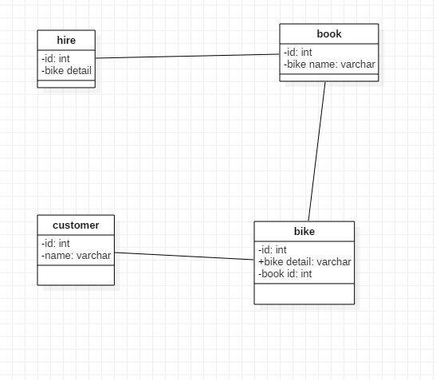

Figure 1: class diagram

This is not finally class diagram. Finally class diagram will be in final documentation.

## 3.1.2 Flow chart

Flow chart is graphical representation of our workflow. This often used in design phase of programming to work out the logical flow of the program. It also a step by step method to solving the problem. That’s why I used flow to my project.

**Justification for this approach**

Here are the some reason how flow chart used in my project.

* It make our logic more clear.
* It helps during writing of programing
* This flow chart is very helpful to make testing and debugging easy
* It is best way of representing sequence of steps in an algorithm

**Notation used**

This are notation use in this flow chart

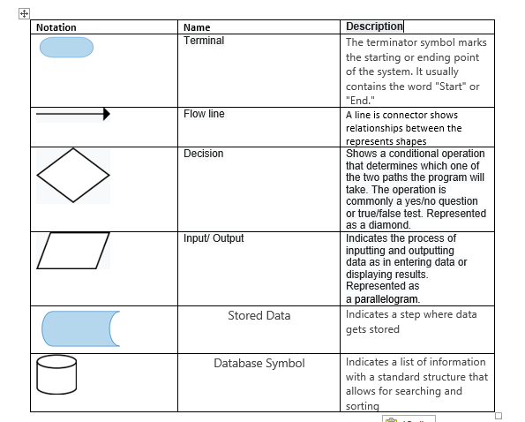

**Diagram**

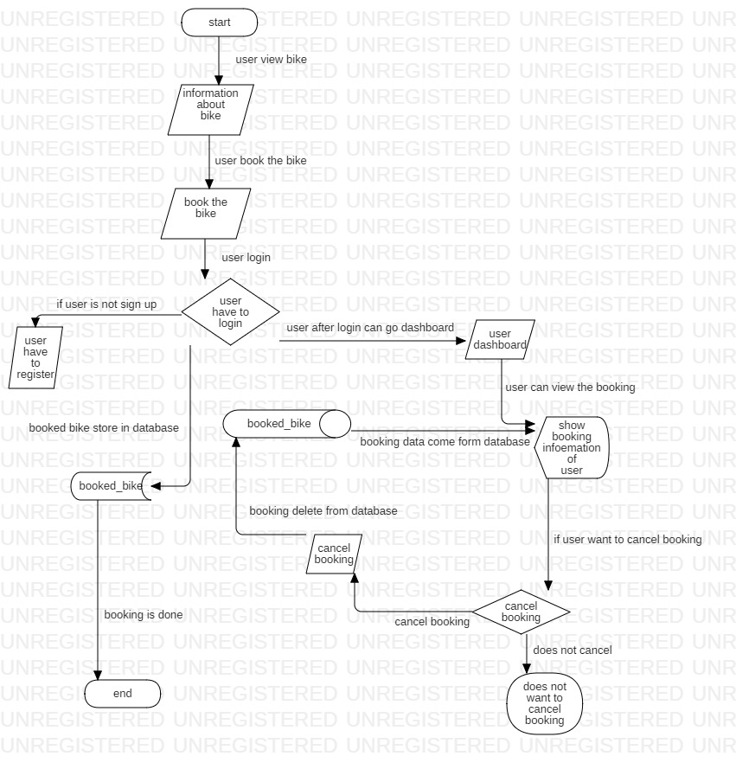

Figure 2: flow chart

In this flow show the how user book bike. Firstly user view the information about bike then booked the bike for rent. To book the bike user have to login if user have to register to do login. After login user can book the bike. After login user can go to dashbord and view bookinf if user want then cancel the booking aslo. Booked bike data will store in database. If user cancel the booking then booking data also remove from database.

# 3.2 Behavioral Modeling

It is dynamic behavior of the system. It show what happens or what is supposed to happen when a system responds to a stimulus from its environment.

## 3.2.1 Activity diagram

Activity diagram describe the dynamic aspects of the system. It is basically a flowchart to represent the flow from one activity to another activity.

**Justification for this approach**

Here are some benefits of activity diagram in my project.

* Reveal the logic of an algorithm
* It describe the step completed in UML use case
* It show the show process of business between user and system
* Define the parallel, branched and concurrent flow of the system
* Examining business requirement at future period.

**Notation used in diagram**

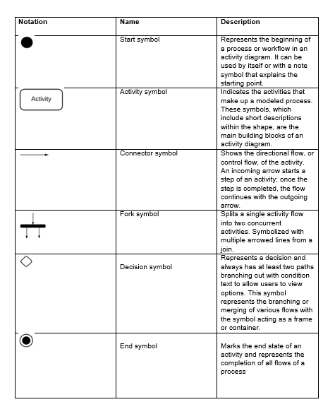

Figure 3: notation

**Diagram**

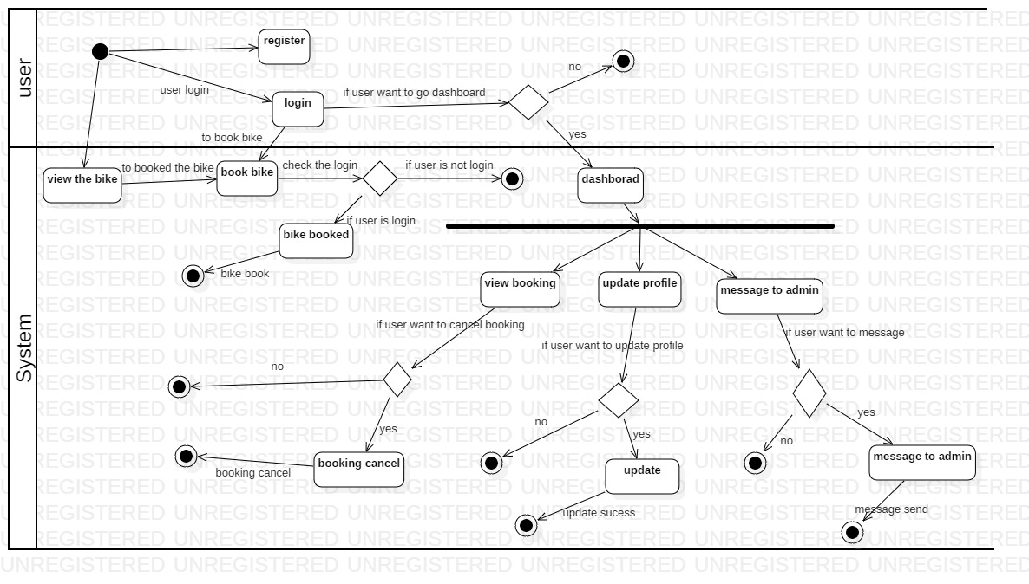

Figure 4: user activity diagram

Here are explanation about figure 2

* User view bike information first
* To book the bike user have login and to login user have to register first
* After login user can book the bike
* If user want the she/he can go to dashboard to view the booking
* User also can cancel booking if he/she wants then
* In dashboard user can update and message to admin

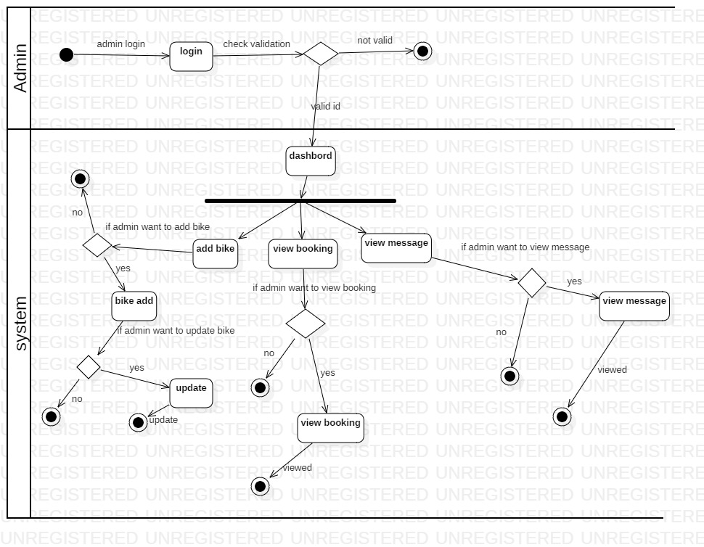

Figure 5: admin activity diagram

In figure 3 show how user interact with system

* Admin have to login to go dashboard
* After login admin can go to dashboard to view booking, view message ,add bike and update bike

## 3.2.2 Sequence diagram

Sequence diagram is an interaction diagram that highlight the time ordering the messages. It also known as timing diagram, event diagram and event scenario.

**Justification for this approach**

Here are some reason why sequence diagram is benefits for my project.

* It helps makes model the logic of a knowledgeable method, function, or operation
* We can know about how objects and components interact with each other to complete a process
* If you consider a service to be a high-level method used by different clients, a sequence diagram is an ideal way to map that out
* Sequence diagram helps to make our system more logically.

**Notational used**

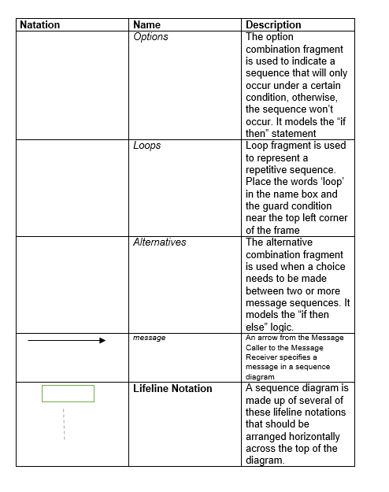

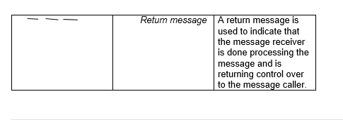

Figure 6: notational used

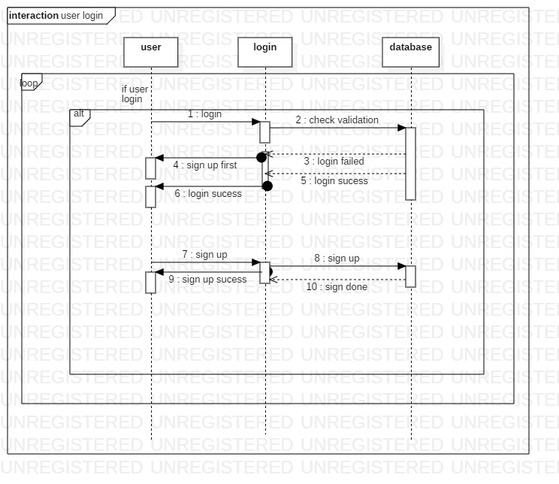

Figure 7: sequence diagram

In this sequence diagram

* User login to system then system check the database
* If login is valid then login success and else not then user have to sign up
* After sign up user can login

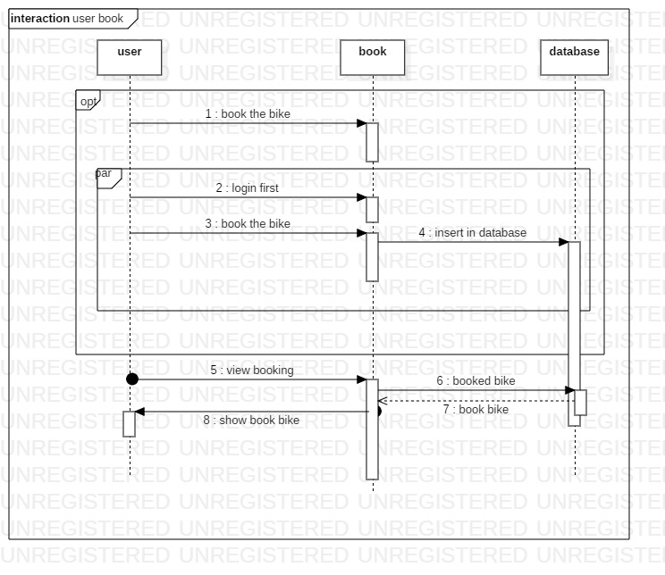

Figure 8: sequence diagram2

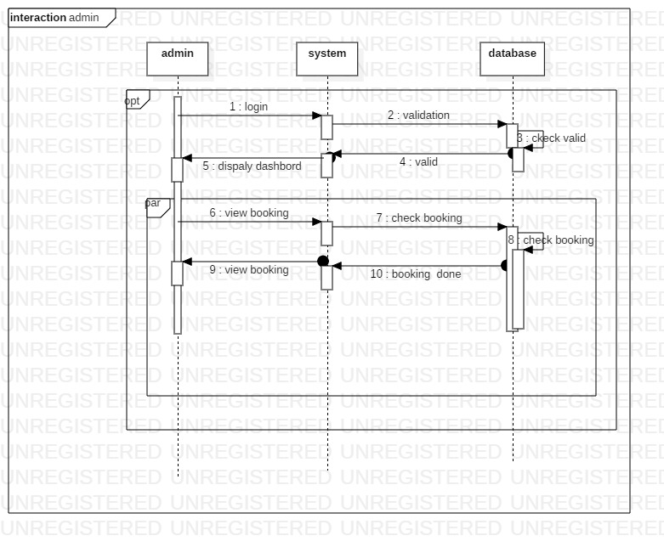

Figure 9: sequence diagram3

Figure 7

* Admin have to login.
* After login admin can view the booking

## 3.3.1 Data Dictionary

Data Dictionary is structured place to keep details of contents of data flow process and data store.

Here are data dictionary of my project

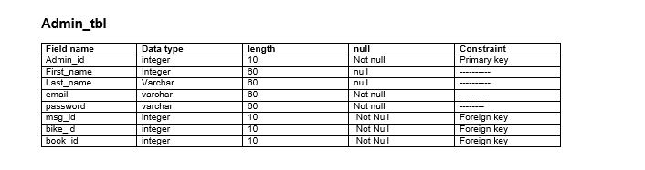

Figure 10: admin

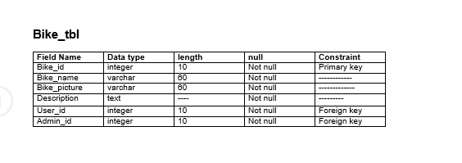

Figure 11: bike table

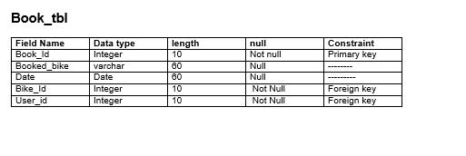

Figure 12: book table

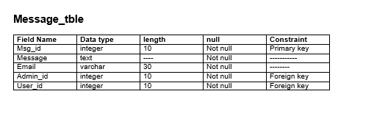

Figure 13: message table

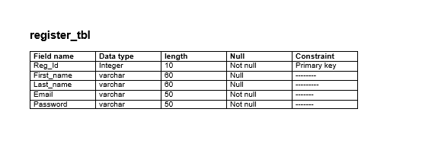

Figure 14: register table

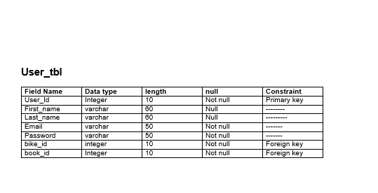

Figure 15: user table

## 3.3.2 ER diagram

Entity Relationship Diagram (ER diagram) is consists of collection of basic object called entities and of relationships among these objects and attributes which define their properties.

**Justification for this approach**

Here are some reason ER diagram is important for my project.

* ER diagram helps to design the database. By looking the diagram we can find the problem and make correction before performing in database
* It help in database debugging by making ER diagram we can easily know the entities, their attributes and relationship with each other. By analyze this we find out the problem easier

**Diagram**

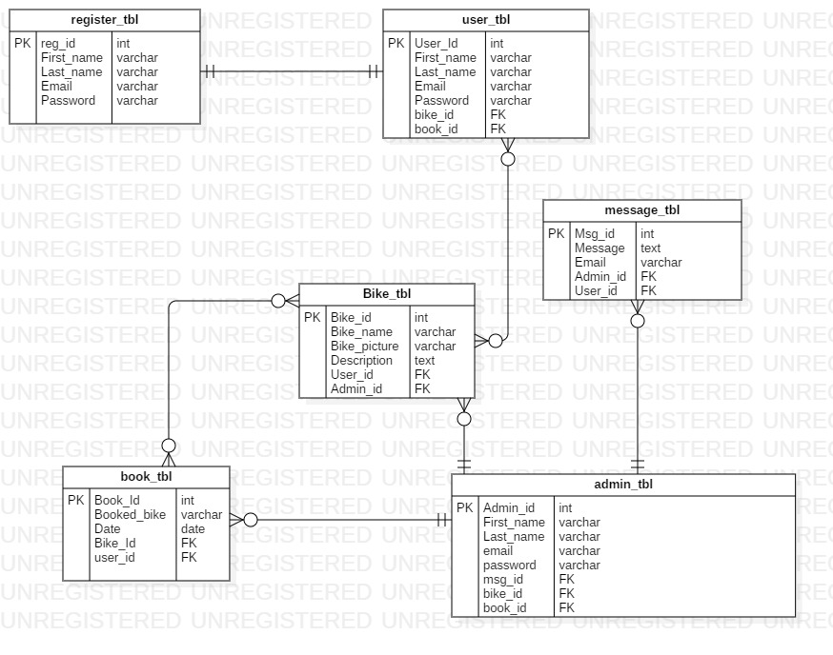

Figure 16: ER diagram

**ER Diagram explanation**

* One user can one register
* Register User can book the bike
* Register can message to admin
* Admin view the book form user
* Admin can view the message
* Admin can add information about bike

# 3.4 UI Mode

User interface (UI) is model of the system how it perform which is show to user for the feedback.

**Justification for this approach**

The reason why UI is design

* It show the mode of the system how it work if user does not like it then it will easier to change the model then system.
* It helps to find out what user want to in system.
* We can find out how the system fit in user daily activity.

**Diagram**

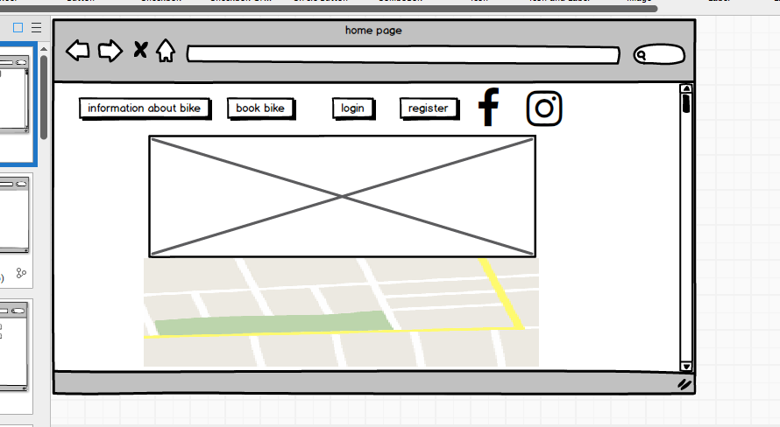

Figure 17: homepage

This homepage of bike rental system in here user can view information about bike, book bike and register and location of the organization.

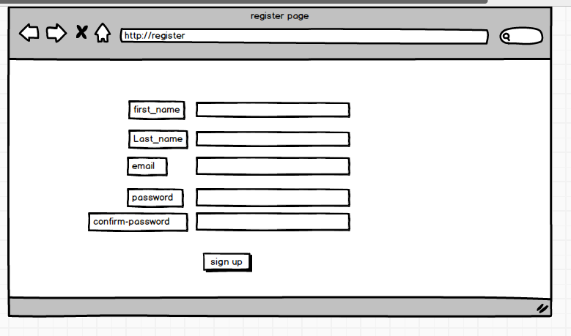

Figure 18: register page

User can sign up then book bike and message the bike

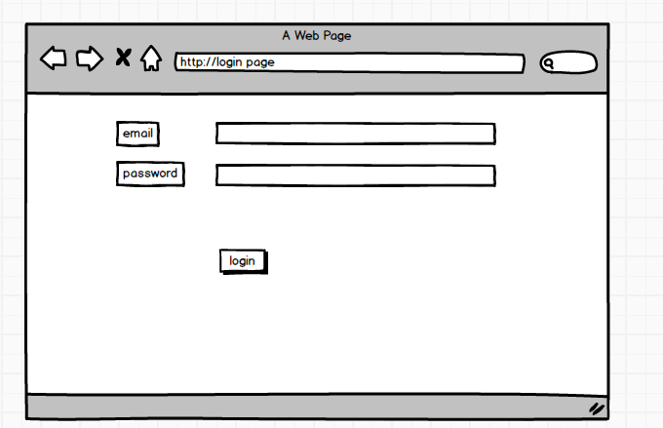

Figure 19: login page for user

This login page to book the bike user have to login

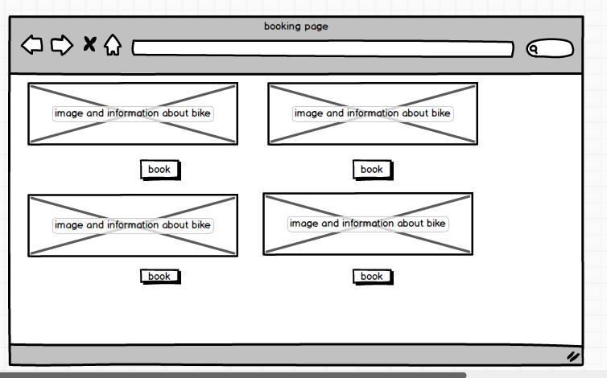

Figure 20: booking page

User can book the bike in this page.

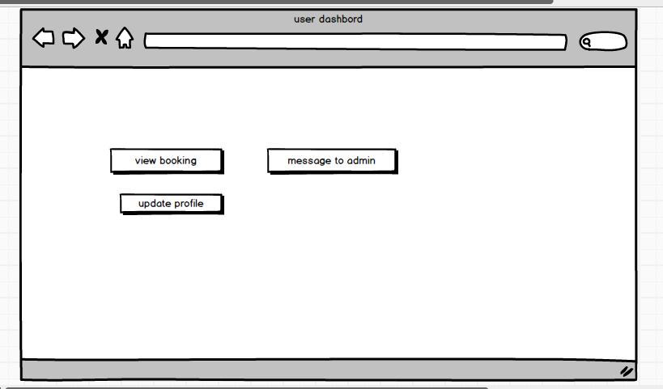

Figure 21: user dashboard

This is user dashboard. User can view the book, message to admin and update profile form this page

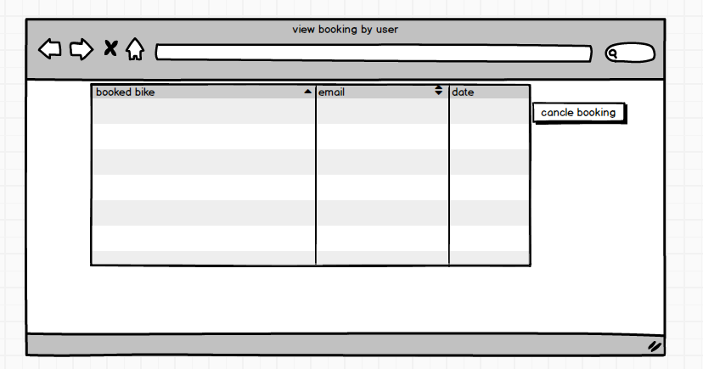

Figure 22: view booking

For user to view the booking. User can cancel the booking if they want

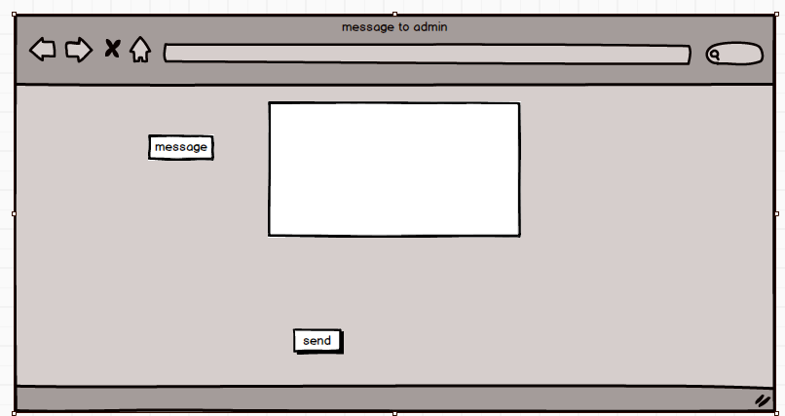

Figure 23: message

User can message the admin

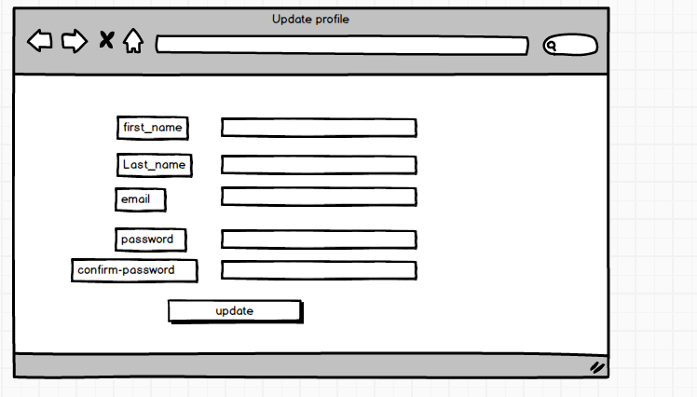

Figure 24: update profile

If user want then they can update their profile from this page

**ad**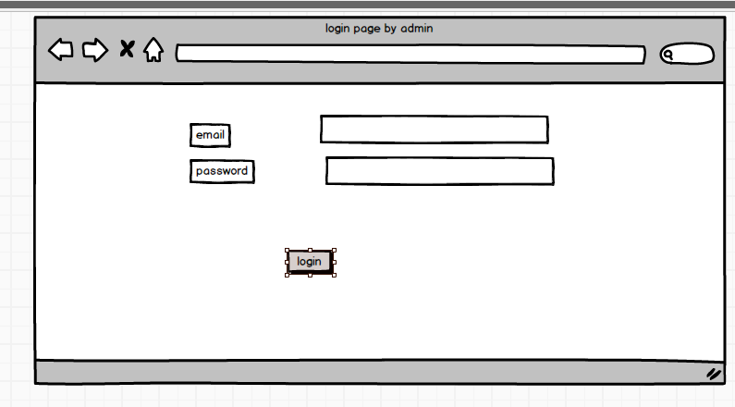

Figure 25: login page

This login page is for admin.

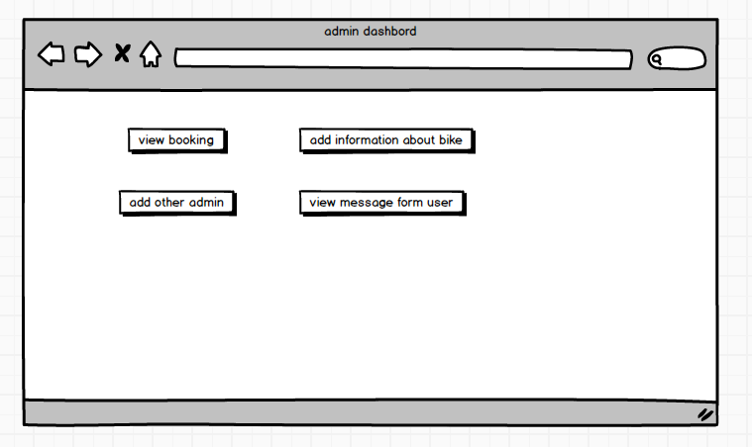

Figure 26: admin dashboard

Admin can add information about the bike, view the booking from the user, view the message form the user and add other admin also.

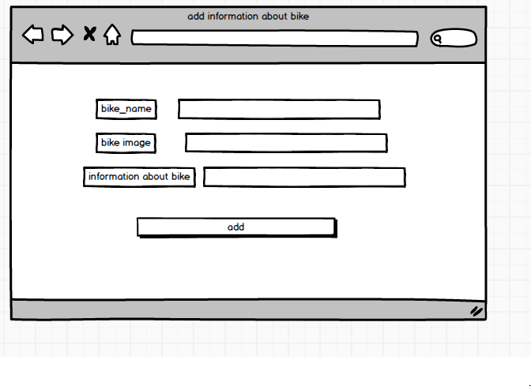

Figure 27: add information

Admin add bike name, image and description about then bike.

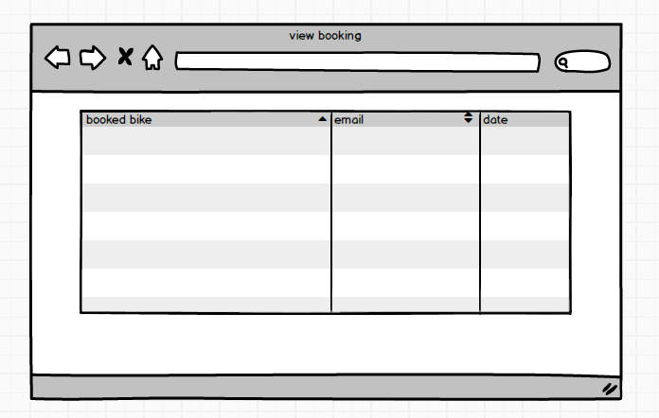

Figure 28: view booking

Admin can view booking from the user

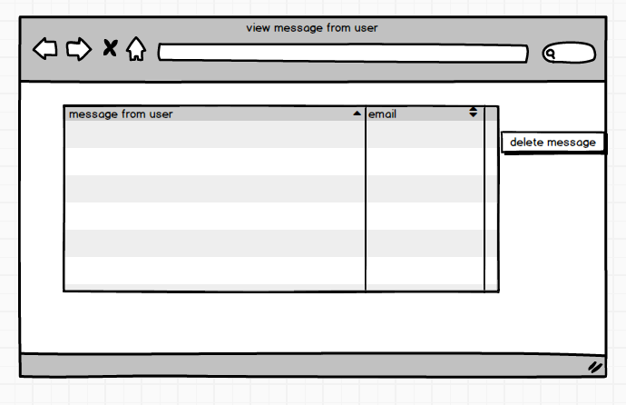

Figure 29: view the message

Messages send by the user view by the user

**Prototype explanation**

So this is prototype of the system. But system will not be exactly like when this prototype can be change if requirement will changes.